k= 2 | silhouette=0.0289 | calinski=3.92 | davies_bouldin=6.7622
k= 3 | silhouette=0.0246 | calinski=3.01 | davies_bouldin=6.8825
k= 4 | silhouette=0.0192 | calinski=2.57 | davies_bouldin=6.7711
k= 5 | silhouette=0.0155 | calinski=2.21 | davies_bouldin=6.4694
k= 6 | silhouette=0.0074 | calinski=2.09 | davies_bouldin=6.1189
k= 7 | silhouette=0.0105 | calinski=2.07 | davies_bouldin=5.6079
k= 8 | silhouette=0.0138 | calinski=2.04 | davies_bouldin=5.4336
k= 9 | silhouette=0.0110 | calinski=1.94 | davies_bouldin=5.2572
k=10 | silhouette=0.0113 | calinski=1.82 | davies_bouldin=5.0080

Saved: /content/clustering_metrics.csv
 | k | silhouette_cosine | calinski_harabasz | davies_bouldin
0 | 2 | 0.028876 | 3.921864 | 6.762209
1 | 3 | 0.024626 | 3.005582 | 6.882530
2 | 4 | 0.019151 | 2.568399 | 6.771093
3 | 5 | 0.015462 | 2.209270 | 6.469360
4 | 6 | 0.007445 | 2.090341 | 6.118856
5 | 7 | 0.010531 | 2.074893 | 5.607859
6 | 8 | 0.013809 | 2.037641 | 5.433576
7 | 9 | 0.010960 | 1.935043 | 5.257203
8 | 10 | 0.011328 | 1.821008 | 5.008020
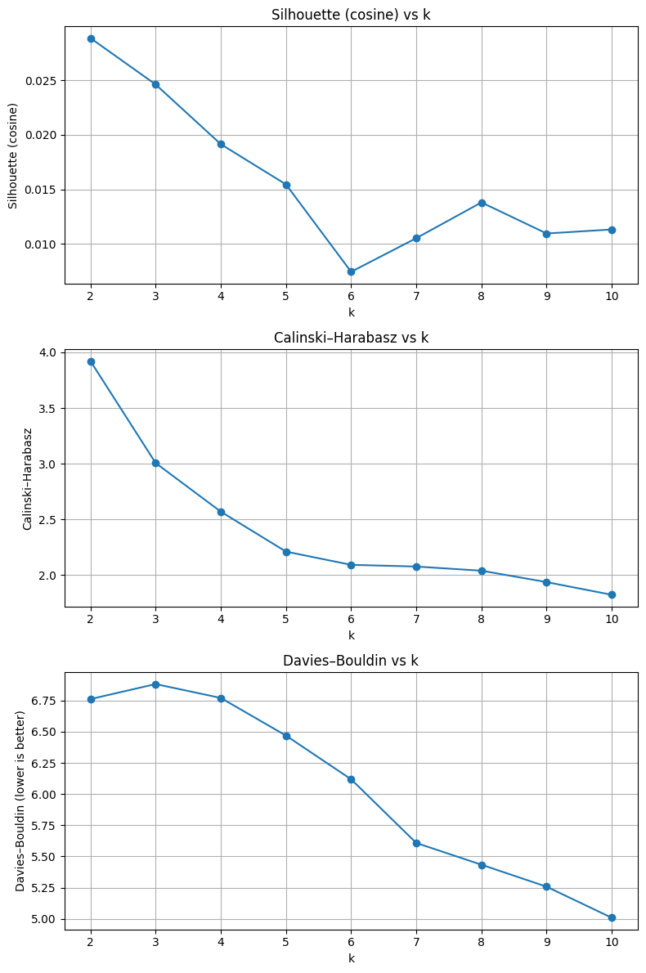

=== Selected k* = 2 ===
Silhouette=0.0289 | Calinski=3.92 | Davies–Bouldin=6.7622

